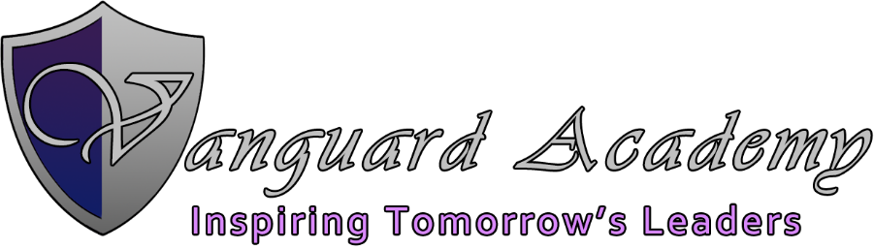

Board Meeting Minutes
Wednesday June 30, 2021
Time: 3:00 P.M.
Location: Vanguard Academy
Present: Kent Johnson, Kim Mangum, Eric Freeman, Darren Jenkins, David E. Kingston
Not in attendance: Scott Kingston, Grace Mitchell

CALL TO ORDER & Pledge of Allegiance- Kent Johnson
PUBLIC COMMENT –
CONSENT ITEMS-

Directors Report –
- We are enrolled to full capacity. We did not have to conduct a lotter this year
- There were 12 problems found on our last audit which we are working with the state to resolve each of them.
Approve final 2021 budget and 2022 original budget–

- John went over the changes made to the budget which were adding the amounts for June. Kim Mangum motioned to approve the final budget for 2021 and 2022 original budget, Eric Freeman seconded it. The voting was unanimous and the budget was approved.

Motion: Darren Jenkins motioned to close, Kim Mangum seconded it, the voting was unanimous and the meeting adjourned.

End Time: 3:21 PM

